**MDSC-103**

**Final Lab Test**

* Formulate the problem in the Excel file and generate the sensitivity analysis

Let **x1 = no. of dozens of baseballs, x2 = no. of dozens of softballs**

Max: Z = 7x1 + 10x2

Subj to:

5x1 + 6x2 <= 3600

X1 + 2x1 <= 960

0 <= x1 <= 500, 0 <= x2 <= 500

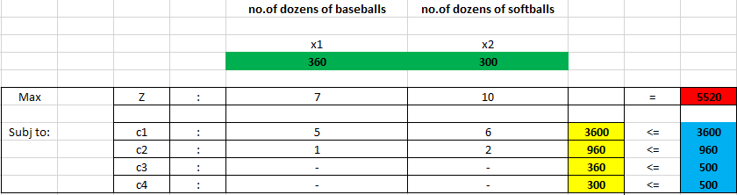

**The sensitivity report for the above simplex problem is:**

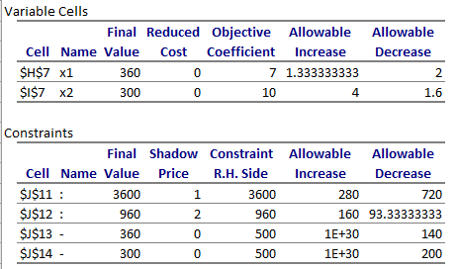

* Write on cost coefficient sensitivity analysis.
  + - For x1:

The price of baseball can be increased by a maximum of 1.33 units until which the solution remains optimal.

Can be decreased by a maximum 2 units until which the solution remains optimal.

Any increment or decrement beyond the above values will change the optimal solution.

* + - For x2:

The price of softball can be increased by a maximum of 4 units until which the solution remains optimal.

Can be decreased by a maximum of 1.6 units until which the solution remains optimal

Any increment or decrement beyond the above values will change the optimal solution.

The reduced cost for both the balls is 0 which is means there is no additional profit associated with their production.

* Write on Right Hand Side Sensitivity Analysis
  + - For c1(cowhide):

Can be increased its usage by a maximum amount of “280” square feet and for each increase it contributes 1 unit towards objective function since its shadow price is 1.

Can be decreased by a maximum of “720” below.

* + - For c2(time):

An additional amount of “160” minutes can be used and for each additional minute it contributes 2 units towards the objective function.

Can be decreased by a maximum of “93.3” minutes.

C4 and C3 can be increased by any amount but does not have any effect in maximizing the profit since their shadowed price is 0.

C3 and C4 can be decreased by a maximum of 140 and 200 respectively without any effect on the profit, below which the optimal solution changes.

